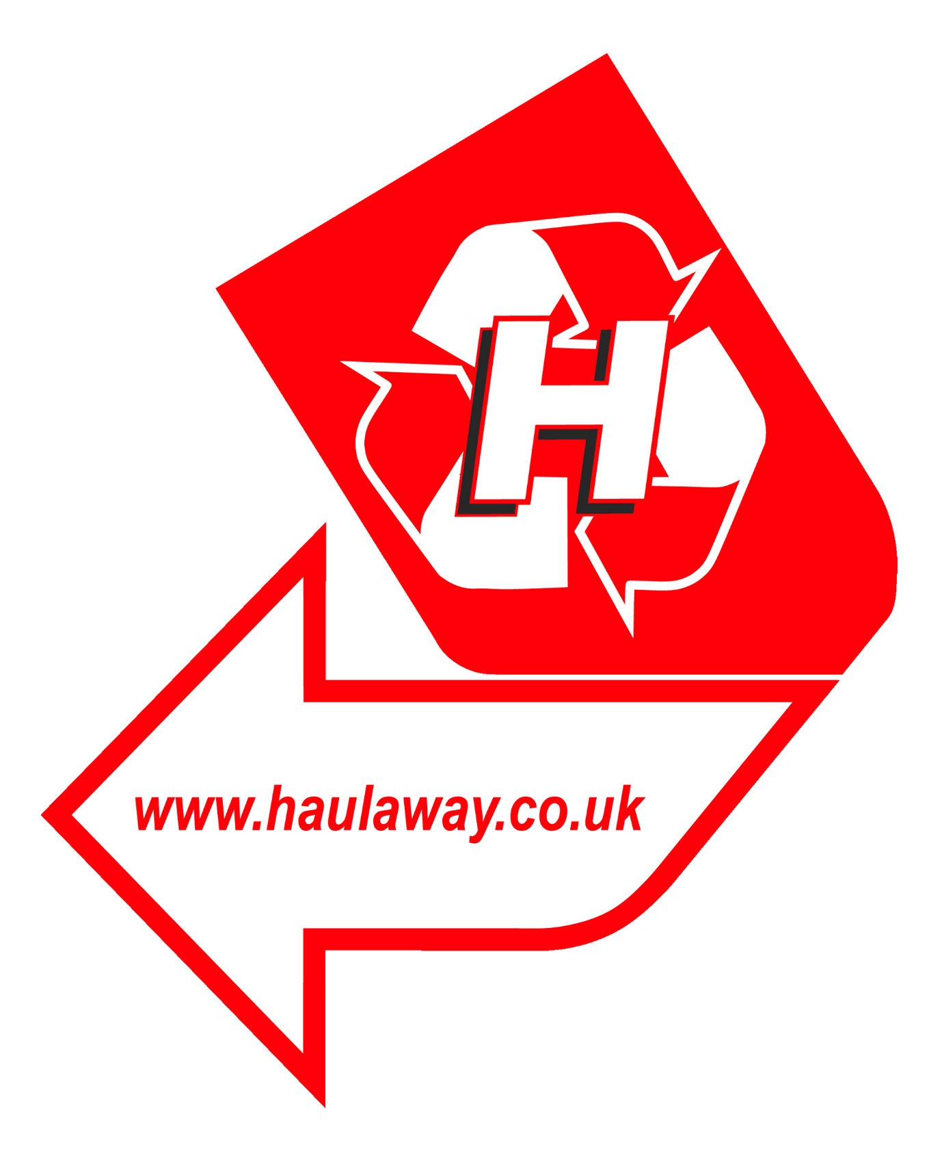
Haulaway Ltd
Mission Statement

“To reduce co2 emissions from incineration and landfill with efficient and effective recycling ethos and innovation”

To become a leading innovative waste management and recycling company in East Sussex, committed to continuous improvement for the company itself, our customers, and the environment around us, supporting customers in complying with current and new legislation.
With the support of our employees, we will aim to grow the company incorporating to reduce co2 emissions from incineration and other disposal points with efficient and effective recycling ethos and innovation leading to 100% recycling, whilst maintaining successful, long standing business partnerships with both our contractors and our customers.

Our Objectives:
- To provide the people expertise, and resource to ensure a first-class service to our customers.
- To satisfy our customers’ agreed requirements in every respect.
- To continuously monitor and improve our performance at a reasonable cost.
- To make a fitting contribution to the community and environment in which we live and conduct our business.
- To continue as one of the largest family run operators in East Sussex whilst still maintaining family values on which the company was founded.

